Unit Quiz
Wired for Data

Name:_________________________ Period:___ Date:________ Score:_____/45

- (2 pts.) Describe each block in this program and describe what the program will do:

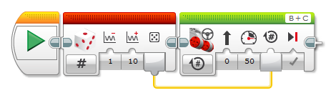

- (3 pts.) What is a variable?

- (3 pts.) Why are variables important?

- (2 pts.) A Logic Loop will repeat when the Logic value wired into it is...
  - Yes/True
  - No/False
  - Wired
  - Missing

- (2 pts.) The Logic Loop allows you to...
  - Make a loop that exits based on a custom condition you specify with logic
  - Combine multiple numeric values into one
  - Control more motors
  - Activate sensors more frequently

- Ziffle’s program below is supposed to stop after the Touch Sensor is pressed or after a certain number of rotations.
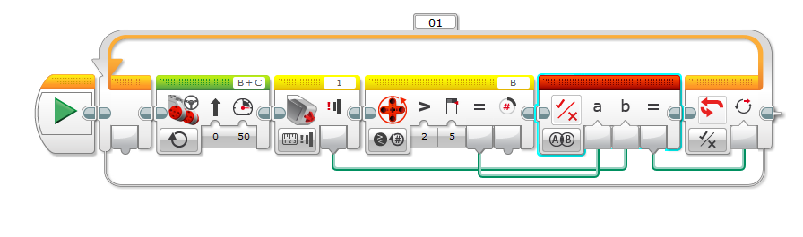
  - (4 pts.) How many rotations will this program run?

  - (4 pts.) Why will this program fail to respond correctly?

  - (4 pts.) What will this program actually do?

  - (6 pts.) How should it be fixed?

- (3 pts.) Which sensors are we measuring in the block below?

- (3 pts.) In the block below, how often will a samples be taken?

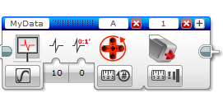

- (3 pts.) What is the difference between a variable and a constant?

- (3 pts.) The program below is not really doing what Ziffle wants. What should he do to get better results?
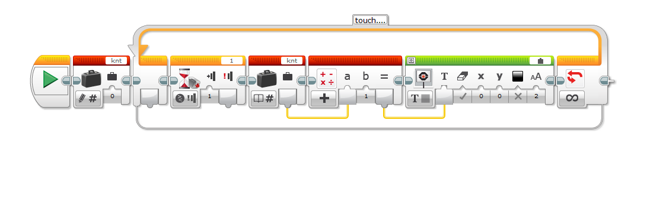
- (3 pts.) What happens in the first KNT variable block?

